# CGP Megamenu Shortcode

Last updated: July 15, 2021

Directory location: /wp-content/themes/phlox/includes/cgp-mega-menu/

Include via: /wp-content/themes/phlox/functions.php

## 1 - Description

* A shortcode that displays a simple accessible megamenu using the native WordPress menu system (no plugin required)
* The shortcode is implemented as part of the WordPress theme. It is included via the phlox theme’s functions.php file (/wp-content/themes/phlox/functions.php)
* Certain layouts/features can be modified by adding css classes to the WordPress menu (see table below)
* The megamenu is based on the Accessible Mega Menu developed by Adobe:
  + <https://adobe-accessibility.github.io/Accessible-Mega-Menu/>

## 

## 2 - Shortcode Usage

### [cgp-mega-menu]

**Description:**

Displays a native WordPress menu as an accessible megamenu

**Parameters:**

| **Name** | **Description** | **Valid Params** | **Default** |
| --- | --- | --- | --- |
| menu-name | Name of the wordPress menu to display. | string | Does not include a default |
| mobile-menu-text | The text to display to screen readers when the mobile menu is displayed | string | Menu |

**Example:**

[cgp-mega-menu menu-name="Custom Mega Menu 1 - En" mobile-menu-text="Menu"]

## 3 - Menu Layout Settings

| **CSS Classes** | **Applied To** | **Description** |
| --- | --- | --- |
| cgp-menu-cols | 1st level nav items | Display child navigation items in columns |
| cgp-menu-row | 1st level nav items | Display child navigation items in a row |
| cgp-mega-menu-heading | 2nd level nav items |  |
| cgp-mega-menu-item-spacer | 3rd level nav items | Adds spacing above menu item |
| **Other Settings** | **Applied To** | **Description** |
| Manu item description field | 3rd level nav items | Adds a tooltip to a menu item |

## 4 - Screenshots

### A) WordPress Menu Settings

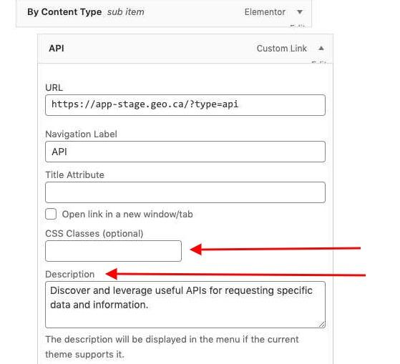

### B) CSS Classes - Row

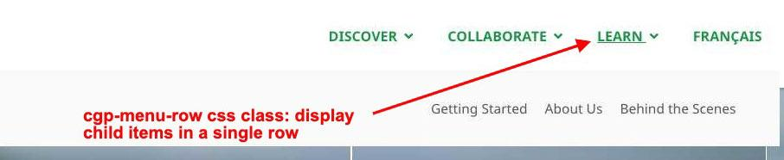

### C) CSS Classes - Column

